Reading Flat Key Signatures

The Flat Symbol (b) sits on the line or space of the note it makes flat.

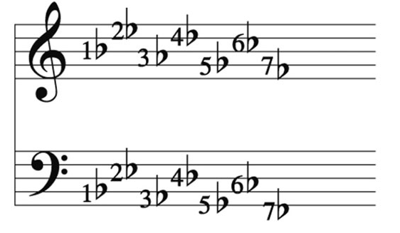

Flat #1 makes all B’s flat (high OR low)

Flat #2 makes all E’s flat (high OR low)

Flat #3 makes all A’s flat (high OR low)

Flat #4 makes all D’s flat (high OR low)

Flat #5 makes all G’s flat (high OR low)

Flat #6 makes all C’s flat (high OR low)

Flat #7 makes all F’s flat (high OR low)

The flat will seem invisible in the music since it is only shown in the key but it IS still there!
- If you have Flat Symbol #1 & 2 in your key, which notes are flat?

- If you have Flat Symbol #1, 2 & 3 in your key , which notes are flat?

- If you have Flat Symbol #1, 2, 3 & 4 in your key , which notes are flat?

- If you have Flat Symbol #1 , 2, 3, 4, & 5 in your key , which notes are flat?

- If you have Flat Symbol #1 in your key , which note is flat?

- If you have Flat Symbol #1 , 2, 3, 4, 5 & 6 in your key, which notes are flat?

